Weekly Update
November 21, 2018

THIS SUNDAY
This week’s guest minister will be Joe Culpepper.
He will be preaching on Psalm 100 and Romans 8:22-28.

Joe Culpepper and his wife Ellen retired in 2011 as pastors of Centennial Christian in Bloomington. They have two grown children & seven grandchildren. Joe currently serves as Regional Elder for the Decatur Cluster, Chair of the CCIW Ministerial Ethics Committee, volunteers at the Salvation Army homeless shelter, & on the boards of several community organizations. His hobbies include bicycle touring, choral singing, community theater, & duplicate bridge.

MINISTERIAL CANDIDATE TO GIVE THE SERMON ON DECEMBER 9TH
The Search Committee has invited Mat Bowen to preach on December 9th. Mark your calendars to attend. We look forward to welcoming Mat and his wife, Elizabeth, on the afternoon of Saturday, December 8th through our worship service on Sunday. We are excited for the opportunity for Mat and Elizabeth to get to know us, visit our church, and show them our community. We have been very impressed with Mat and we look forward for the opportunity to get to know him better.

HUSTLERS
The Hustlers will meet this Sunday at 7:00pm at the home of Jim & Sue McClard.

SEEKERS SUNDAY SCHOOL
The Seekers Sunday school class will not meet on Sunday, November 25th or Sunday, December 23rd.

SERVING SUNDAY NOVEMBER 25TH
Elders: David Hagan, Arlen DeWall, Don Eberly
Deacons: Adam Kincaid, Lori Rinehart, Sue McClard
Beth Tabor, Leah McClure, Jay Kristensen
Worship Leader: Matt Barnard
Communion Preparation: Sue McClard
Home Communion: Arlen DeWall and Sue McClard
Greeters: Harold & Jalene Medler

WORSHIP LEADERS AND GREETERS
Please consider serving as a greeter or worship leader in December. A sign-up sheet can be found in the narthex.

SUNDAY DECEMBER 2ND
JAKE'S BOYS & FIRST SUNDAY OF ADVENT
Sunday, December 2nd will be a very special day for the First Christian Church Family. Jake's Boys will be our guests in the worship service bringing their wonderful singing which they share all over the area. It is also the first Sunday of Advent. At the close of the worship service we will open the beginning of the season of advent by the lighting of the first candle in our advent wreath. We will continue on with the preparation of decorating the sanctuary for the Advent Season in joy and thankfulness for the birth of our Lord and Savior, Jesus Christ. After completing the decorating, we will gather in the fellowship hall for a light lunch. Please join us on this special day.

YOUTH GIVE THANKS
This past Sunday, our elementary students discussed being thankful in all things as we reflected on the arrival of Thanksgiving. They created their “Thankful Turkeys” to share what they are thankful for, and why they are thankful.

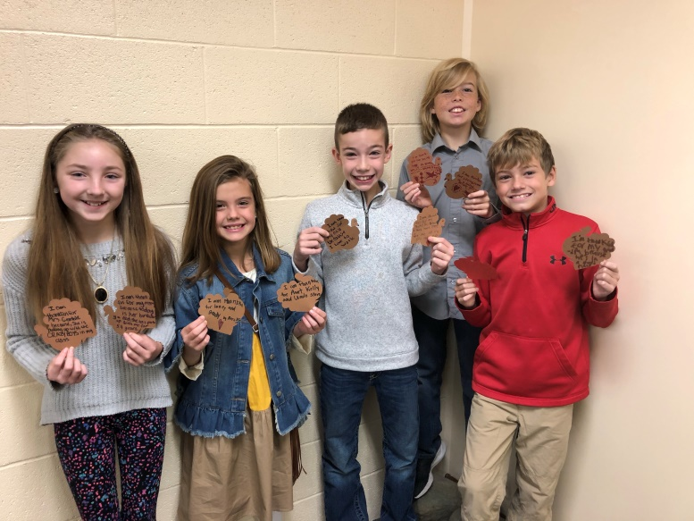

RECYCLING
First Christian Church will be in charge of recycling for the month of December.
Volunteers will be needed on December 1st and December 15th from 8:00-11:30am.
Sign-up will be posted in the narthex.

PRAYER LIST
Rosella Jesse –Hollybrook Apt 42
Bill and Jean Kerchenfaut – new address
6235 Hoffman St #201
North Port, Florida 34287-2285
Harold Stimmel— Hollybrook Apt 34
John Revell
Harriet Farney
Margaret Meers
Patty Benz
Margaret Gambill
Jim McClard
John Weller
Evelyn Fawver
Barb Bennett
Irene Schaefer
Duff Knudsen
Marilyn Lowell

We also continue to pray for the Search Committee
and the Recruitment Committee

SYMPATHY
We express our sympathy to the family of Lila Parsons, who passed away on November 15th.

BIRTHDAYS AND ANNIVERSARIES
(November 21-27, 2018)

November
21: Lane Elder
23: Emily Elder

Please send us (gcfccdoc@yahoo.com) additions or corrections of birthdays,
anniversaries, or email addresses.

FUTURE GUEST MINISTERS
December 2nd: Jake’s Boys
December 9th: Mat Bowen (Ministerial Candidate)
December 16th: Joe Culpepepr
December 23rd: Beth Rupe
December 30th: Herb Knudsen

WEBSITE
The church’s website is now live and can be found at www.fccdocgc.com
On the website, you can view the church video made to help with the search process,
a calendar featuring upcoming events,
and copies of the Weekly Updates and Christian Visitors.

ATTENDANCE
FCC ATTENDANCE |  | SUNDAY WEEK
 |  | 1 | 2 | 3 | 4 | 5 | AVG
2018 | JULY | 46 | 41 | 42 | 41 | 30 | 40
2018 | AUGUST | 48 | 42 | 42 | 45 |  | 44
2018 | SEPTEMBER | 46 | 55 | 48 | 47 | 51 | 49
2018 | OCTOBER | 63 | 68 | 51 | 50 |  | 58
2018 | NOVEMBER | 51 | 52 | 55 |  |  | 53
 | AVG | 50.8 | 51.6 | 47.6 | 45.8 | 40.5

Average Monthly Attendance
 | 2017 | 2018
July | 30 | 40
August | 35 | 44
September | 49 | 49
October | 46 | 58

